MMP Individual Contribution (General)

|  |  |
| --- | --- |
| Student Id/Name | Maham Saeed- 2122865 |
| Group |  |
| MMP Video Link | https://www.youtube.com/watch?v=I7pakVXYC8w |
| MMP Repository Link | https://github.com/UdaraCR/Caring_Hearts.git |

**Individual Report: Software Developer**

**Introduction:** As the software developer in our project to enhance the caregiver task management system, my role focused on adding new features and improving existing functionalities for the MMP (Minimum Marketable Product) phase. This report details my contributions, challenges faced, and lessons learned during this phase.

**Contributions:** Our team collaborated effectively by utilising each member’s skills and maintaining clear communication through WhatsApp and bi-weekly meetings on Microsoft Teams or at the university.

In terms of new feature development, I added task analytics which included charts (area, bar) showing total tasks, new tasks, in-progress tasks, completed tasks, and overdue tasks. I also enabled a view history feature that tracks task updates, including who made changes and when.

For security improvements, I conducted security assessments with the security analysts and implemented necessary fixes. On the backend, I optimised database queries for faster data retrieval and better performance. I provided additional training for GitHub usage, held troubleshooting sessions, managed the project repository ensuring all code updates were documented and version-controlled, and created detailed documentation for new features, including setup guides and user manuals.

**Challenges Faced:** Team members faced challenges balancing the project with other commitments, occasionally causing delays.

Limited resources restricted the implementation of some desired features.

Initial difficulties with GitHub during the MVP phase were resolved, making it easier during the MMP phase. Insufficient early testing led to more bugs being discovered later.

During the MVP submission, we faced difficulties uploading the video presentation. Initially, we uploaded it to the university's OneDrive and shared the link in the report. However, upon review, the tutor encountered challenges accessing the presentation and made it difficult for the tutor to provide feedback. To address this issue for the MMP phase, we've opted to upload the video presentation on YouTube and provide the link instead.

**Lessons Learned:** Regular meetings and proactive communication were crucial. We increased the frequency of meetings and used tools like Microsoft Teams and Slack more effectively. Implementing better version control practices, including comprehensive code reviews and a clear branching strategy, was essential. Adopting an agile approach allowed for quick adaptation to changes and new requirements. Additionally, I gained a deeper understanding of security protocols in web application development.

**Future Work with Additional 12 Weeks:** With an additional 12 weeks, I would focus on:

1. **Further Feature Enhancements:** Adding more advanced analytics and reporting features.
2. **User Feedback Integration:** Continuously improving the application based on user feedback.
3. **Scalability:** Ensuring the application can handle increased user load and data volume.
4. **Advanced Security Measures:** Implementing additional security features to further protect user data.

**Conclusion:** My role as a software developer in this project provided significant opportunities for professional growth. By addressing challenges and continuously improving my skills, I contributed to the successful development of our caregiver task management system.

**Acknowledgments:** I would like to thank my team members for their support and collaboration, and our project manager for their leadership and guidance throughout the project.

Evidence and Appendixes: (Unlimited)

Admin panel

Employee panel

Meeting proof

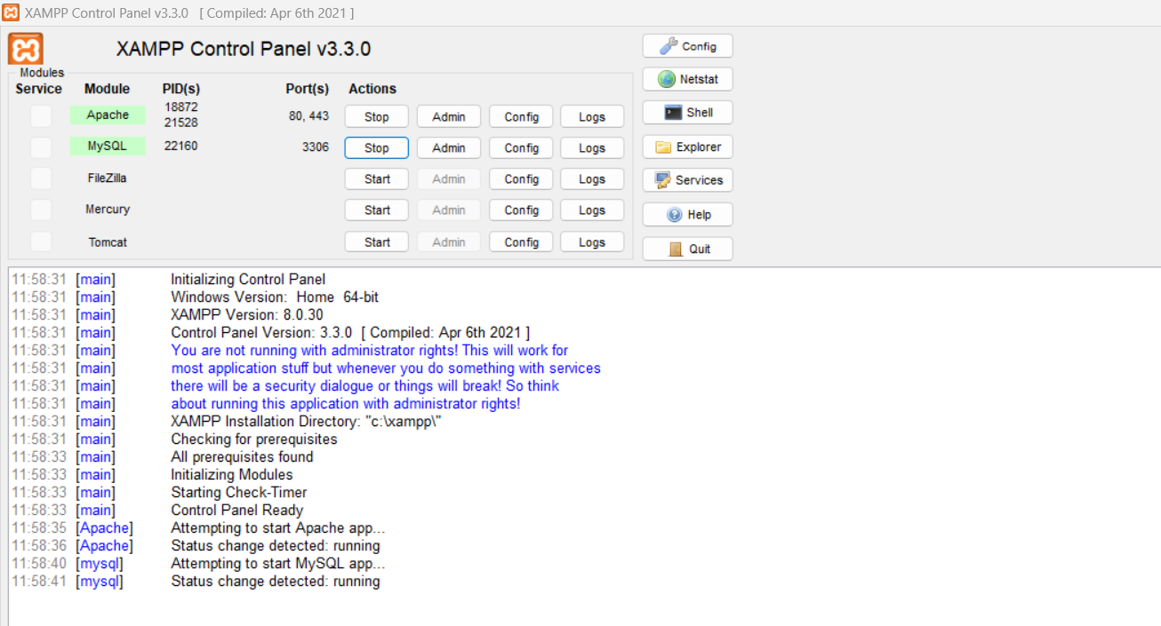

Folder containing all the code

Github repository screenshoot

